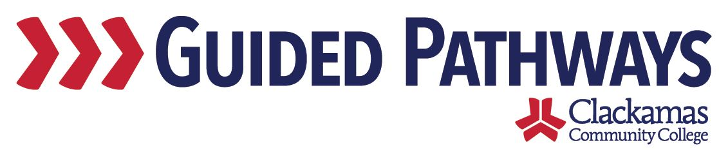
Guided Pathways Leadership Taskforce
Meeting Notes
October 5, 2020, 2:00–3:30 p.m. (Zoom)

- Follow up on previous commitments and updates

- Update & input on Collaborative Advising
- Tara and Dustin presented slides
- Lisa: Are we able to pull colleague reports to find out how many and which students are in each EFA?
  - Yes, Dustin is able to pull those reports. Tara and Dustin will see if others are able to pull those reports.
- Tara took notes of the questions and discussion
- Want to serve any student that comes on our campus – how do we do that in a way that is best for them and is sustainable for us

- Self-assessment feedback & taskforce deliverables
- At the last meeting (in August), we discussed the charter and the roles and responsibilities of taskforce members
- David shared an overview of how he remembers the guided pathways leadership taskforce coming together and how the taskforce really operates
  - At the start of implementing guided pathways, it became clear that this touches all aspects of the college – needed a steering committee that could reflect on and make decisions – David convened the group with the idea that he was delegating his authority for decisions related to guided pathways
  - David’s sense of this group is that when the taskforce comes to a decision, they are ready to bring that decision to College Council, Curriculum Committee, ISP, etc.
- Self-assessment
  - Feedback was shared between the August meeting and now
  - Dawn engaged the group in a Kahoot activity

- Revise GPTF charter
- Reviewed the charter as a large group
  - Taskforce Charge
    - Estimated Hours
    - Audience
    - Team Members
  - Specific Project Deliverables
    - Can we use the self-assessment areas that we said we would scale as the project deliverables?
  - Desired Results
- Broke into two groups – one to work on charge (group 1) and one to work on desired results (group 2)
  - Group 1
    - Nora reported out
    - Ensuring inclusivity and barriers to success – what are we addressing and what are we monitoring
    - How is tracking efforts different from coordinating and evaluating efforts
    - Evaluating efforts – is that oversight of the subgroups?
    - Does the leadership group still meet? If so, what is their role?
    - Specific metrics we’re trying to address within guided pathways – how do we track those metrics
    - What are our goals as a college around guided pathways
  - Group 2
    - Got rid of a little bit of duplication
    - Early momentum and student success indicator targets
    - Took out item that talked about achieving some level of integration – combined with embedded work

- Review commitments and next steps
- Tara and Dustin will follow up with the other guided pathways colleges to see what they’re doing for mandatory advising
- Dawn and Kelly will put together the revised charter and send it out between now and the November meeting

